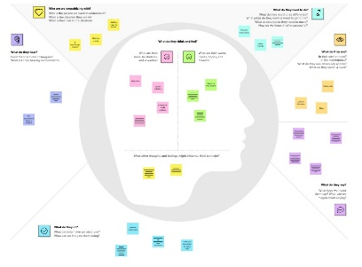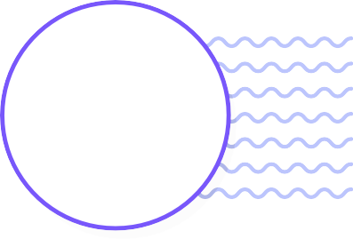

Clean and and healthy environment



People should actively participate in such events



Unhappy about local environment



Self awareness program should be conducted

Happy

about the

initiations. What do see?

promotes agriculture

Lack of cleanliness may lead to the discussion with their friends

People and government should be aware

Knowledge

On water

Pollution

and its

causes like

diseases

**TEAM ID**✴: **PNT2022TMID52011**

**Develop shared understanding and empathy**

Our direct customer is the government who approves and guarantee our project and our indirect customer is the people who river water for different pyrposes such as irrigation, domestic supply, power generation and industry. The aim of our water quality monitoring system is to meet the demand qualitatively and quantitatively.

## What do they HEAR?

## What are hearing others say?

**WHO ARE EMPHASIZING WITH?**

**Who are the person we want to understand**

**What is th are in?**

**What is the role in their suituation**

## GOAL

**What do they THINK and FEEL**

**Pains**

**GAINS**

## What do they need to DO?

What do they need to do differently? What job(s) do they want or need to get done? What decision(s) do they need to make?

How will we know they were succ

usage of

unygienic

water

Originally created by Dave Gray at

Free from diseases,

## Industrial waste What do they SEE?

What do see in the mark

Shortage of

Quality

water

proper u-

nderstandi

of issue

even proper explantion

friends and

family worries. Others active

participation

influence the

people

usage

of non

plastic

bags preventive

actions

they

## What do they DO?

What do they do today?

What behavior have we observed? What can we imagine them doing?

[**Share template feedback**](https://muralco.typeform.com/to/CiqaHVat?typeform-source=app.mural.co)

**Need some inspiration?**

See a finished version of this template to kickstart your work.

[**Open example**](https://app.mural.co/template/018339d6-ff71-42d8-9e5c-abddde77d5ab/982236e0-c7e5-4fb6-83e9-ef1b972b25bd)